**Will Canada’s Greenhouse Gas emissions start declining?**

**Joel Wood**

associate professor, School of Business & Economics, Thompson Rivers University

[**@JoelWWood**](twitter.com/joelwwood)

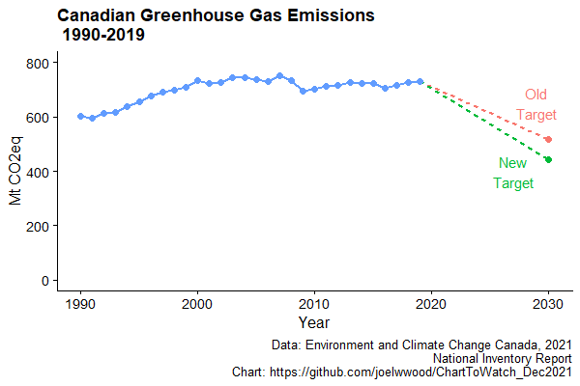

My chart shows Canada’s greenhouse gas emissions for the period 1990 to 2019 (the most recent data available). Since 2015 Canada has had a 2030 target of emissions being reduced by 30% of 2005 levels; however, in 2021 the government announced a more ambitious 2030 target of a reduction of 40-45% of 2005 levels. The chart shows that our emissions are not yet on the desired trajectory. Federal and provincial governments have also implemented substantial carbon pricing policies and other regulatory policies, as well as announced plans for many additional policies. I will be watching this chart in 2022 since the 2020 data release will show the impact on greenhouse gas emissions of the COVID-19 pandemic and accompanying public health responses. And I will be continually watching this chart in the years to come to see if Canada’s emissions begin to decrease towards our targets, old or new.